ASSIGNMENT- 7.3
NAME: B.Vaishnavi
BATCH: 28
H.No.: 2303A51657

Lab 7: Error Debugging with AI
Systematic approaches to finding and fixing bugs
Task 1: Fixing Syntax Errors
Buggy Code (missing colon):
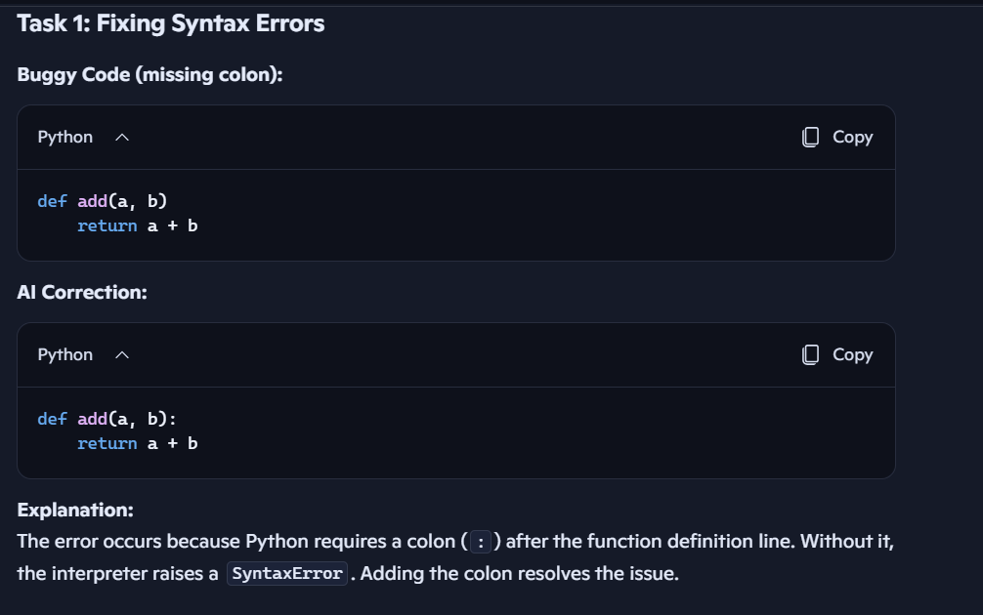
Task 2: Debugging Logic Errors in Loops
Task 3: Handling Runtime Errors (Division by Zero)
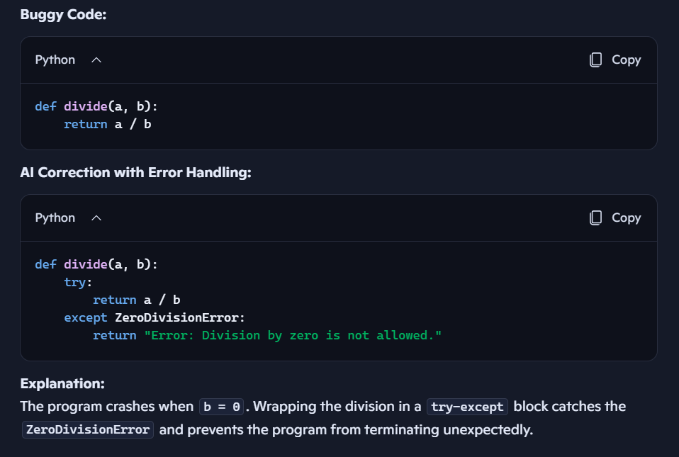
Task 4: Debugging Class Definition Errors
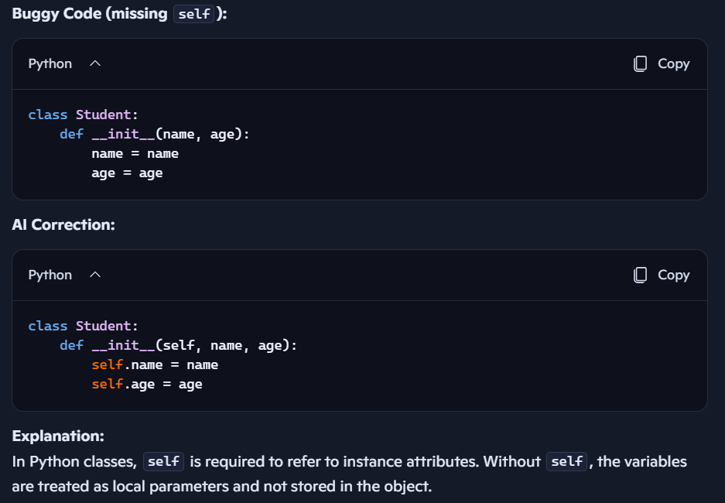
Task 5: Resolving Index Errors in Lists
